Practical 1 : Data Consolidation
Objective: Combine data from two sheets into one summary sheet by items.
Step 1: Prepare the data
- Jan sheet
- Go to sheet tab at the bottom
- click on + icon
- right click to rename it to Jan
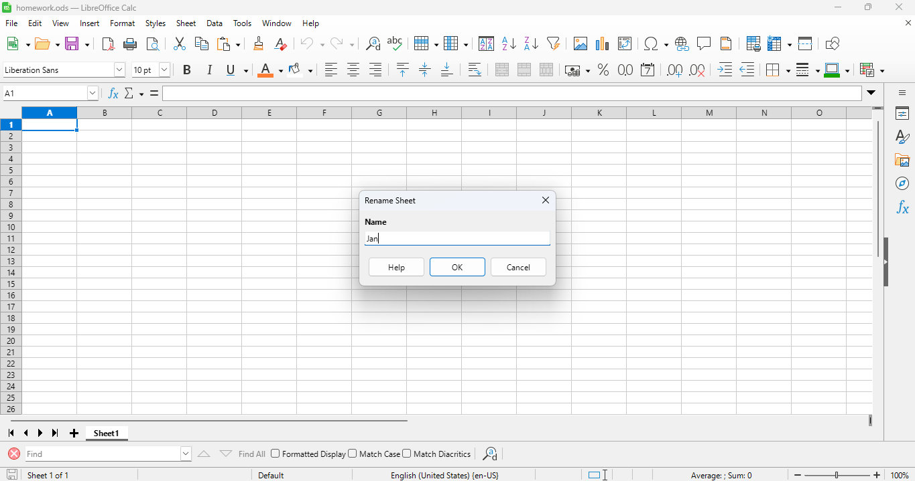

- Enter the details like items, Quantity, Amount
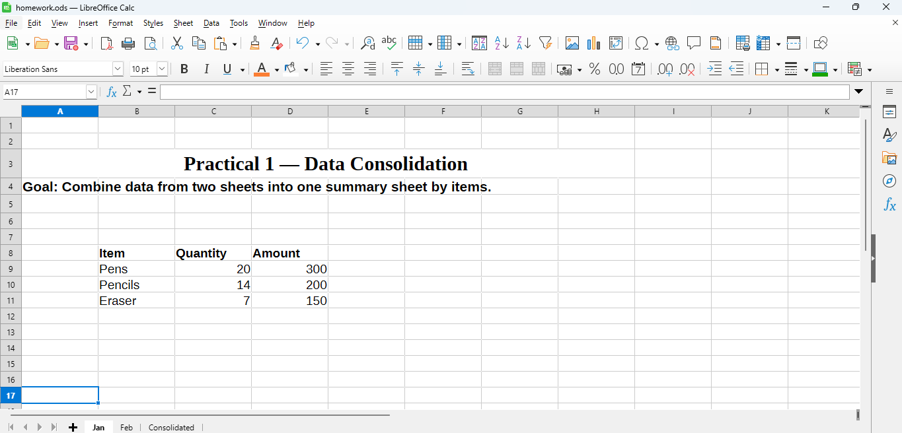

- Make another sheet for feb sales same like above
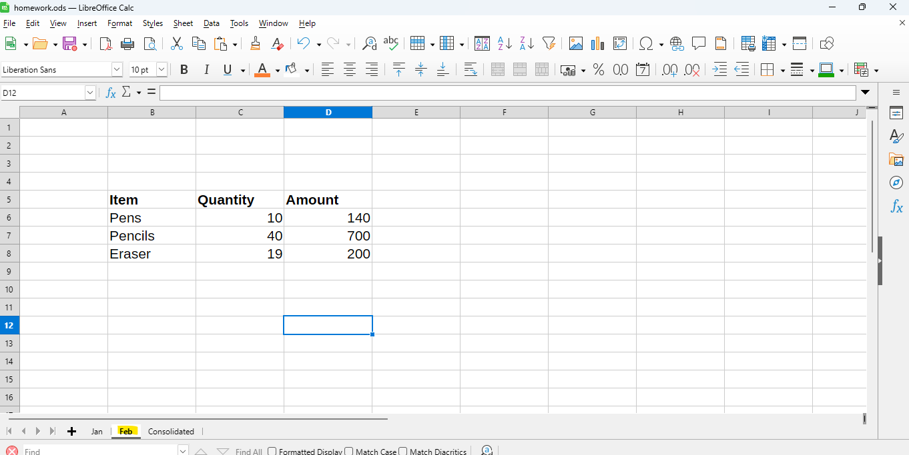

Step 2 : Create a new sheet
- Insert a new sheet and rename it Consolidated.
- Click in cell A1 — this is where the combined data will appear.

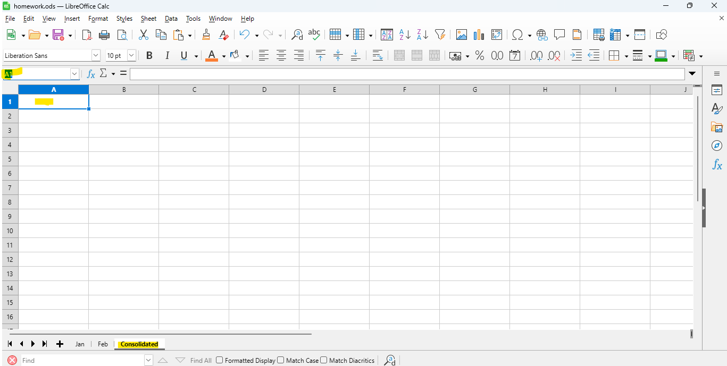

Step 3: Open the Consolidate dialog
- Go to the top menu:
Data → Consolidate…
- The Consolidate dialog box will open.

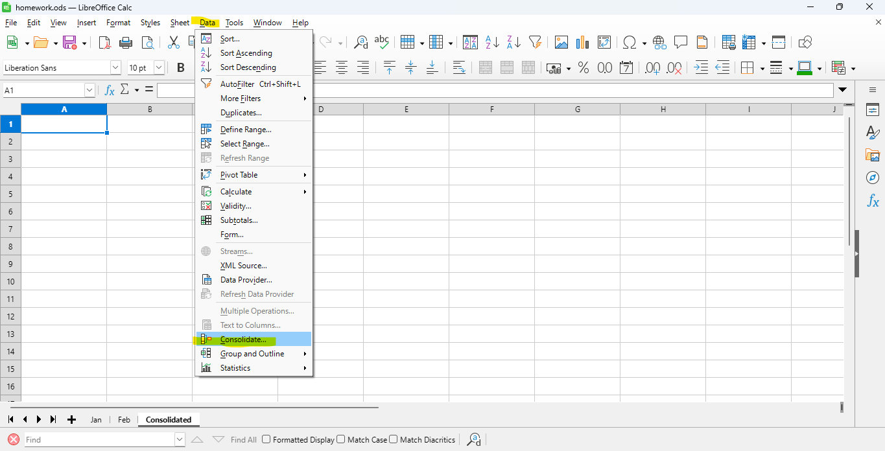

Step 4: Add source ranges
- Click inside the Source data range box.
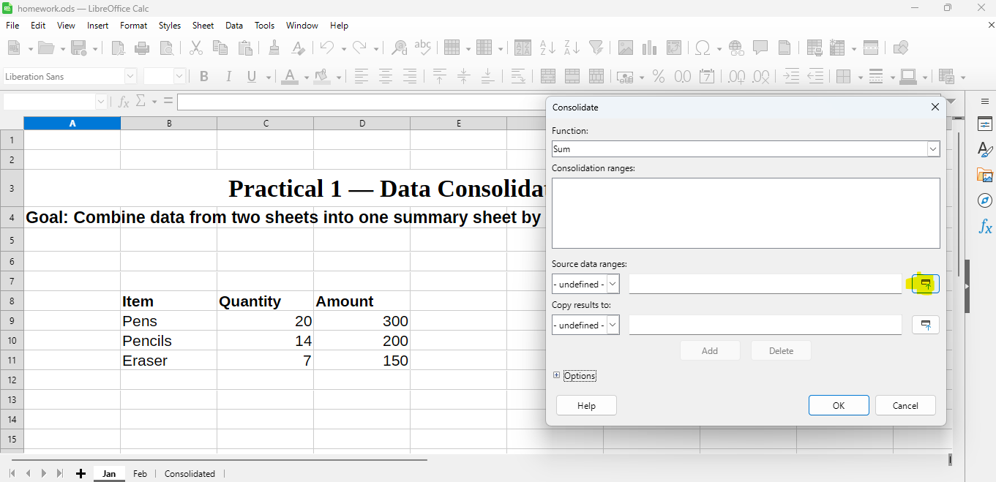
- Go to the Jan sheet → select the range B8:D11.
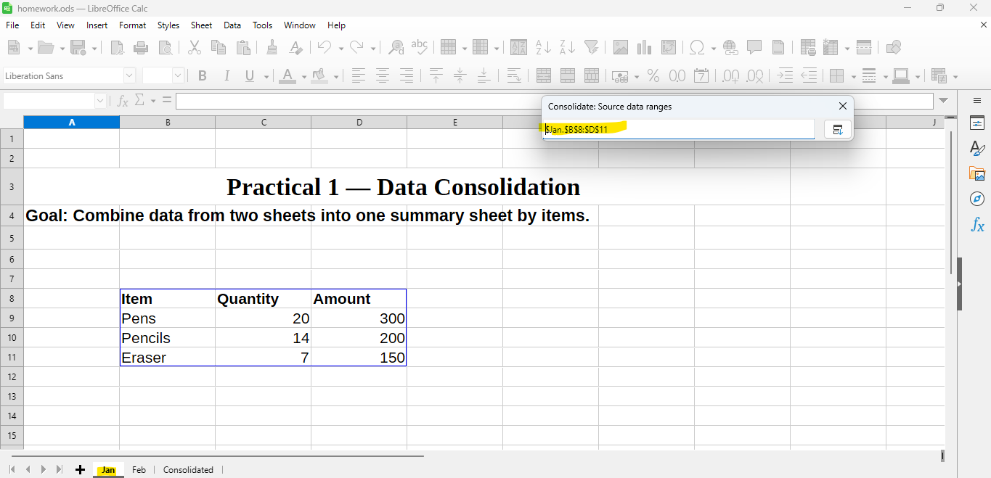
- Click the Add button in the Consolidate dialog.
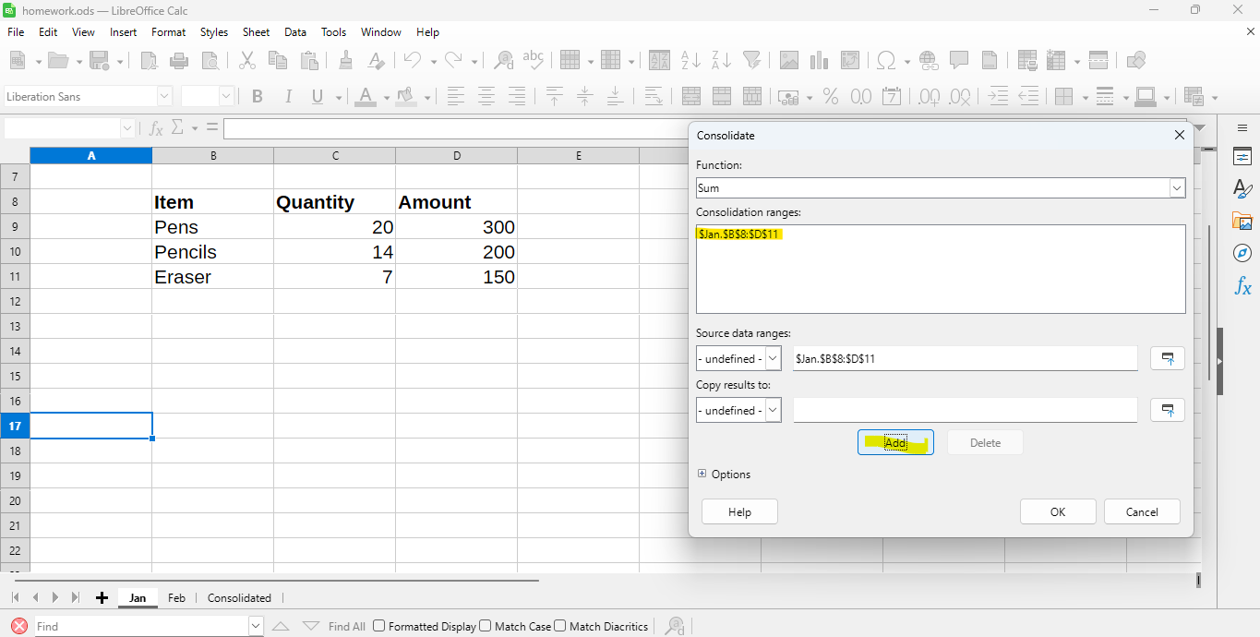
- Now go to the Feb sheet → select B5:D8 → click Add again.
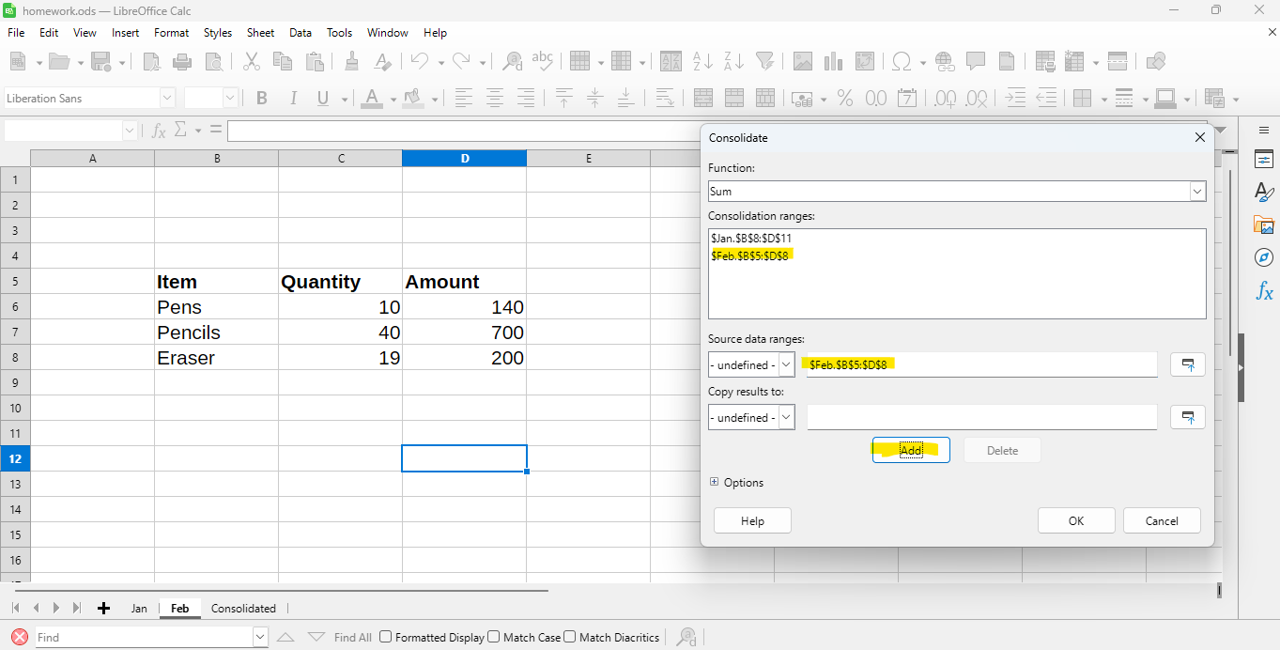

Step 5: Choose the Function
In the dialog:
- Under Function, select Sum (default).
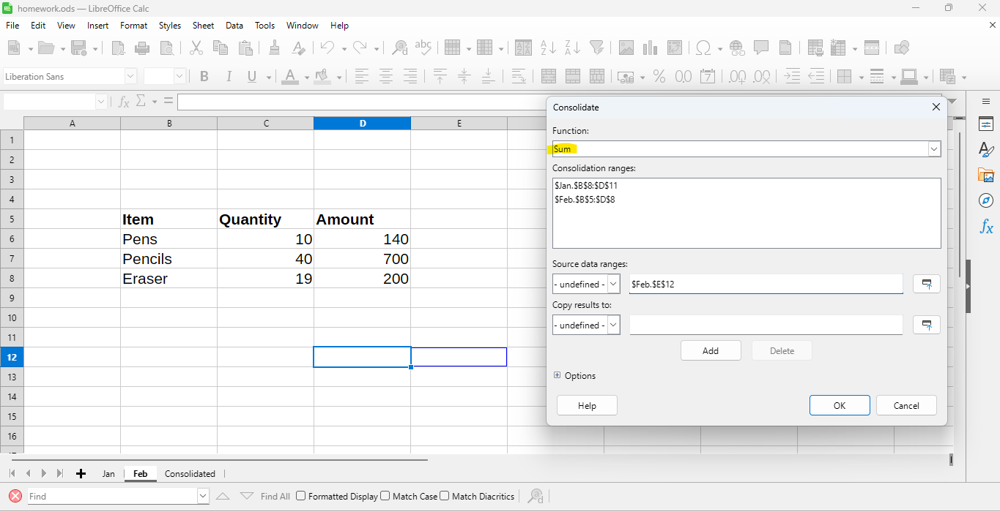
Step 6: Output location
“Copy results to” points to the correct cell in Consolidated sheet (for example $Consolidated.$A$1).
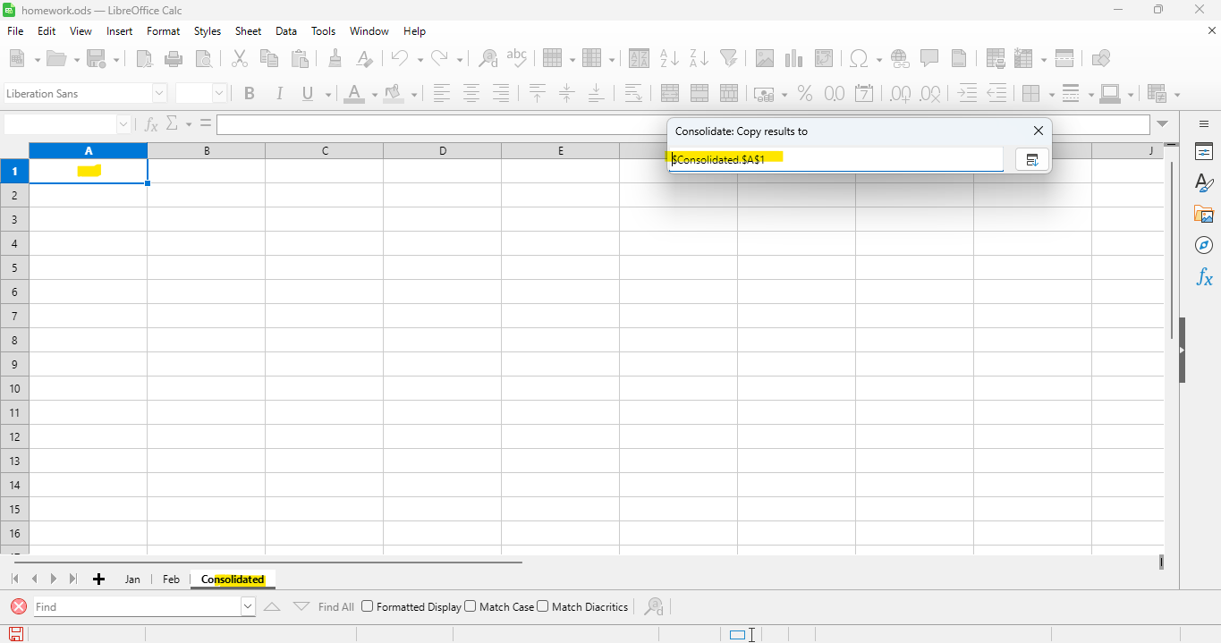

Step 8: Click Ok
Calc will automatically:
- Combine the data from both sheets.
- Match items by name.
- Add up the quantities and amounts.
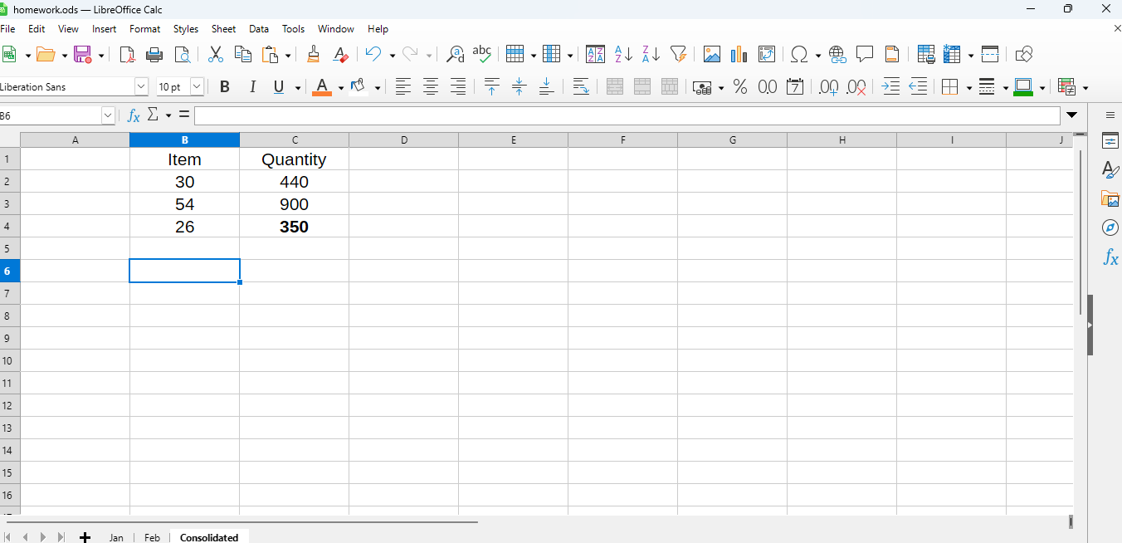

Practical 2: Macro Function
Objective: To record and run a simple macro in LibreOffice Calc that performs formatting automatically, and to create a basic user-defined macro function using LibreOffice Basic.
Step 1: Open a new spreadsheet
- Open LibreOffice Calc.
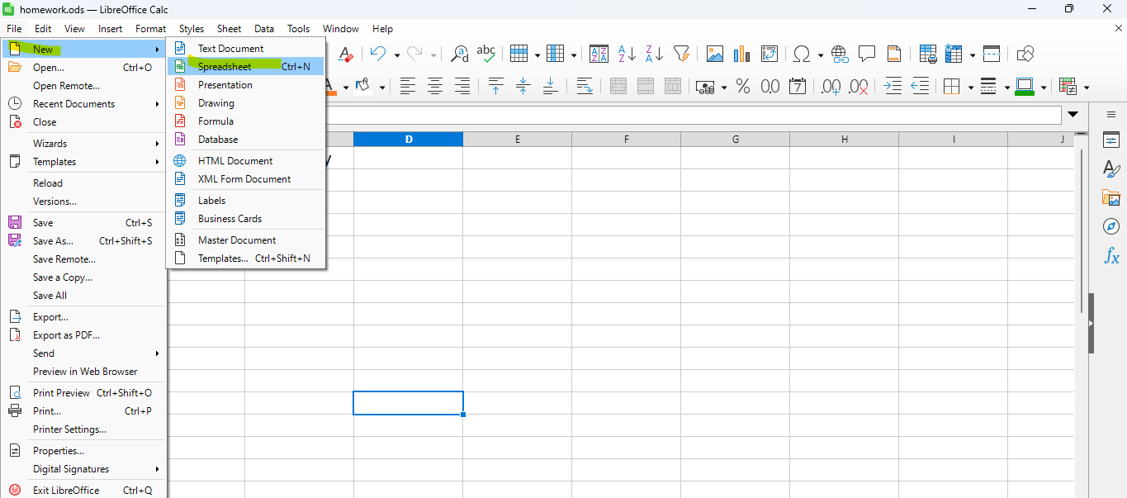
- Save it as Macro_Function.ods
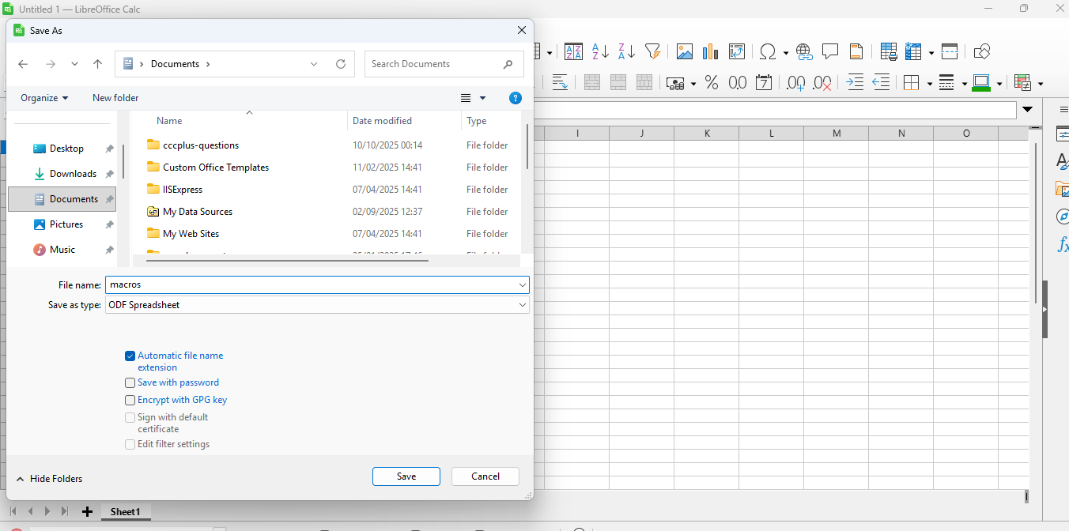
- In the sheet, type this data:
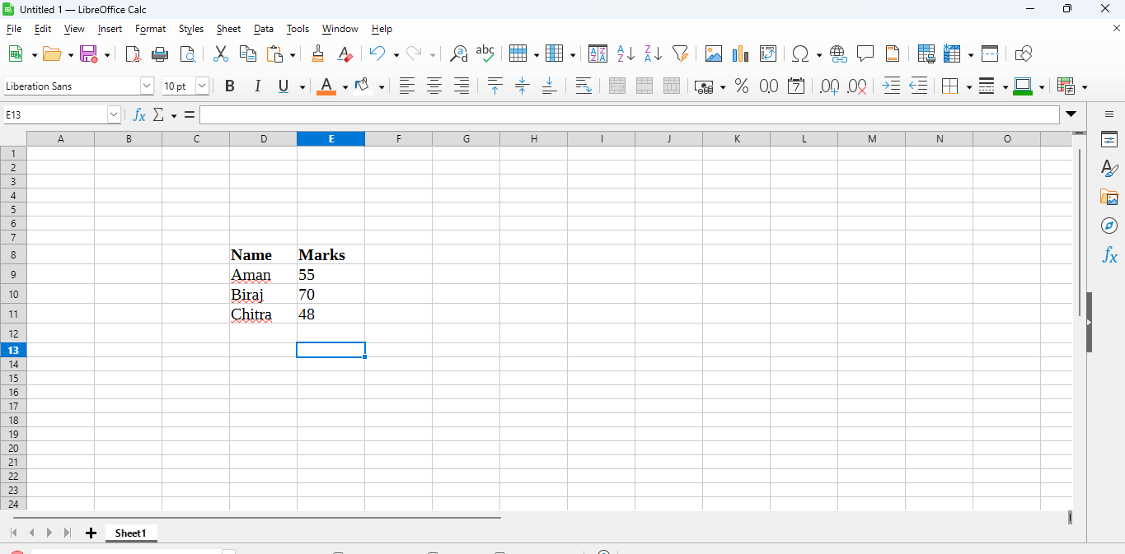
Step 2: Enable Macro Recording (important!)
Before recording, make sure macro recording is turned ON.
- Go to
Tools → Options → LibreOffice → Advanced and Check “Enable macro recording (limited)”
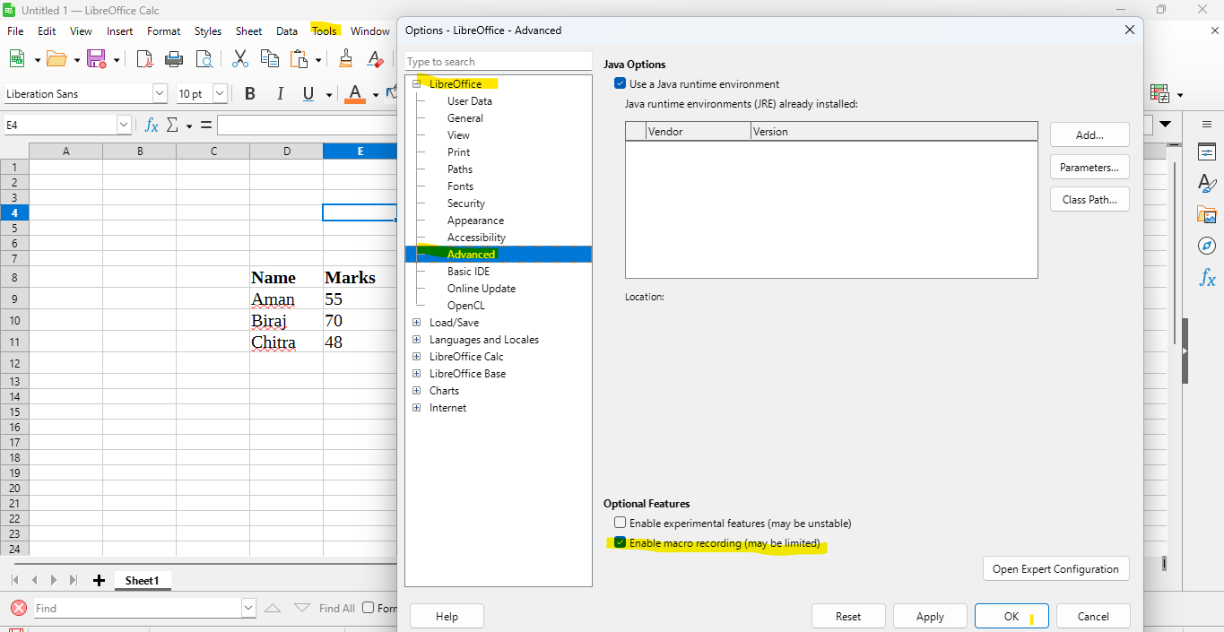
- Click OK and restart LibreOffice Calc.

Step 3: Start Recording the Macro
- Select Tools → Macros → Record Macro
- 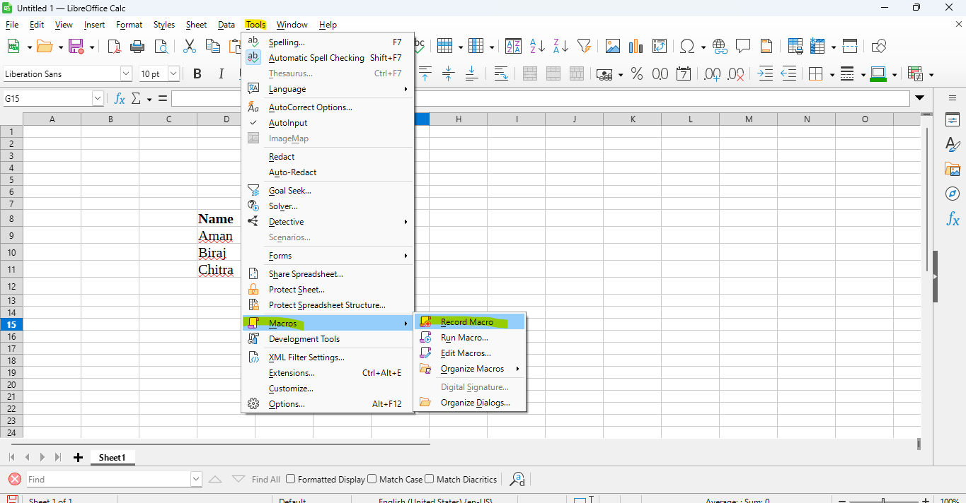
(You’ll see a small floating window appear.)
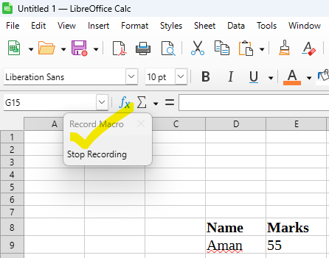
- Now perform some formatting actions, for example:
  - Select cells A1:B1
  - Make them Bold
  - Apply a background color (Format → Cells → Background)
  - Center align the text (Format → Align → Center)
- When done, click Stop Recording in the small recorder window.

Step 4: Save the Recorded Macro
- After clicking stop, a dialog box appears.
- Choose:
  - Save macro in: This Document (Macros.odf)
  - Create a new module named Module1
  - Save macro name as: FormatHeader
- Click Save.

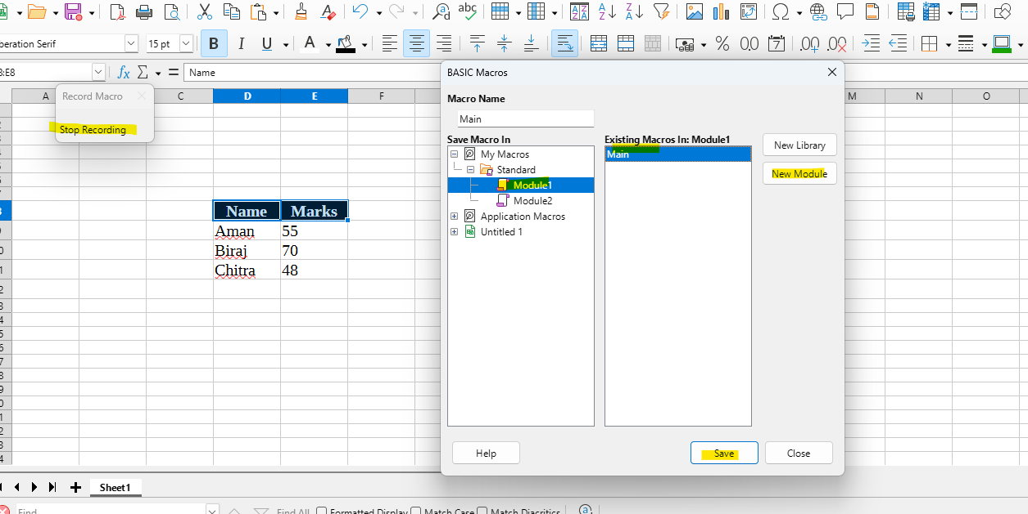

Step 5: Run the Macro
- Now go to: Tools → Macros → Run Macro
- Navigate to:
- Macros.odf → Standard → Module1 → main
- Click Run
→ Your header row formatting is applied automatically!
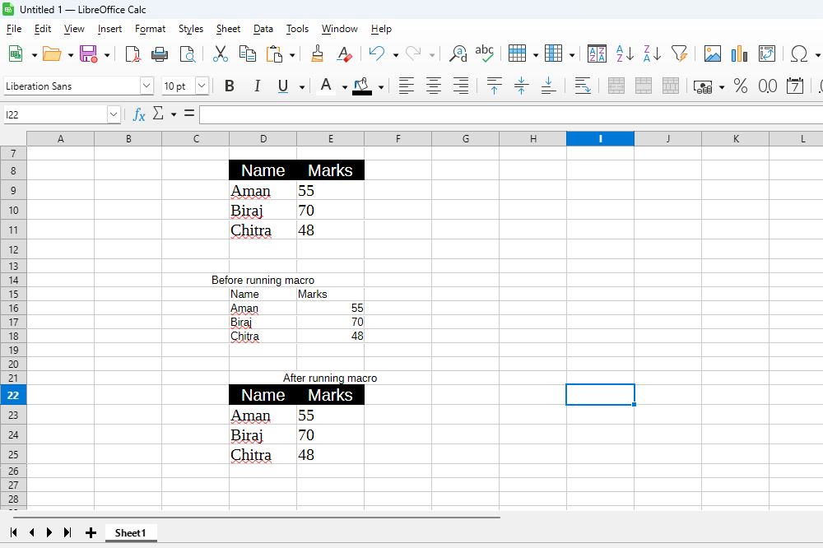

Practical 3: Multiple Operations
Objective: You are given marks of 10 students in 5 subjects (Math, Science, English, Social Science, Hindi). Create a workbook to:
- Calculate Total Marks and Percentage (out of 500) for each student.
- Assign a Grade using the scale: >=75 → A1, 60–74.99 → A2, 45–59.99 → B1, 33–44.99 → B2, <33 → Fail.
- Compute Class Average (%) and Class Highest Total.
- Determine each student’s Rank by total marks (1 = highest).
- Highlight students who scored < 33 in any subject (use conditional formatting).

Step-by-step instructions and formulas
- Total (column G)
  - In cell G2 enter:
=SUM(B2:F2)
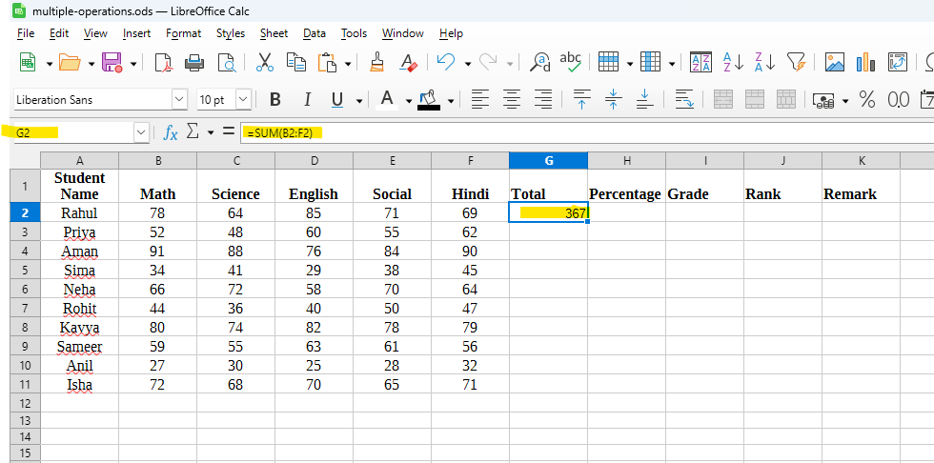
  - Drag (fill) down G2 through G11.

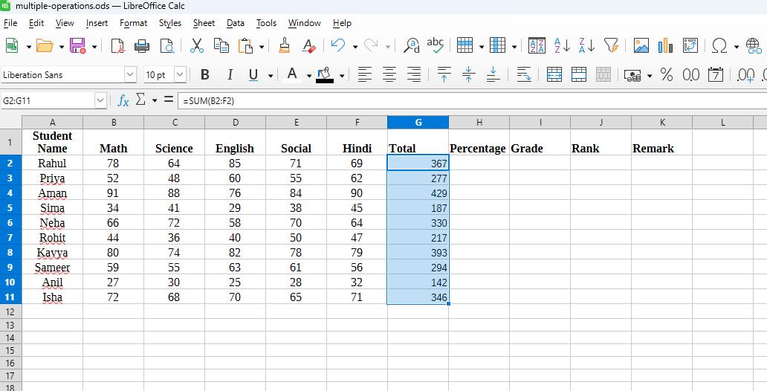

Percentage (column H)
- In H2 enter (rounded to 2 decimals):
=ROUND(G2/500*100,2)
- Fill down H2:H11.

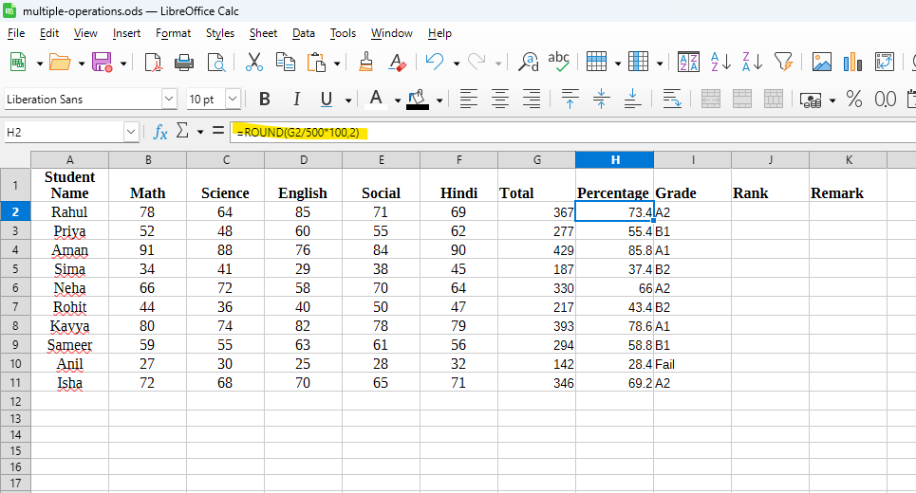

Grade (column I) using nested IF:
- In I2 enter:
=IF(H2>=75,"A1",IF(H2>=60,"A2",IF(H2>=45,"B1",IF(H2>=33,"B2","Fail"))))
- Fill down I2:I11.
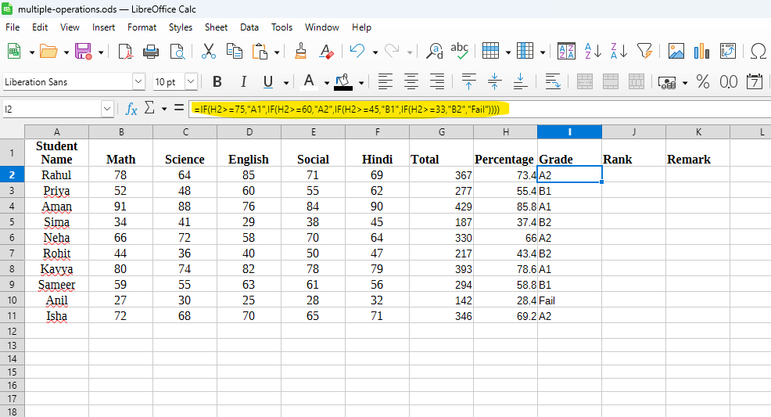

Rank (column J) (1 = highest total):
- In J2 enter:
=RANK.EQ(G2,$G$2:$G$11,0)
(Excel) — For LibreOffice use =RANK(G2;$G$2:$G$11;0)
- Fill down J2:J11.
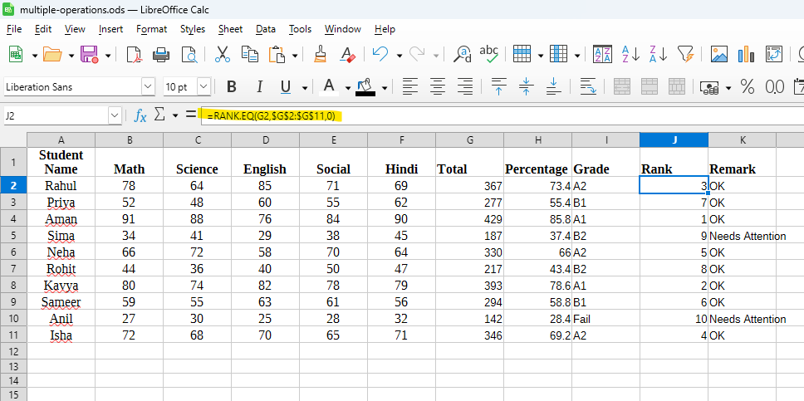

Remark (column K) — to flag if any subject < 33:
- In K2 enter:
=IF(OR(B2<33,C2<33,D2<33,E2<33,F2<33),"Needs Attention","OK")
- Fill down K2:K11.
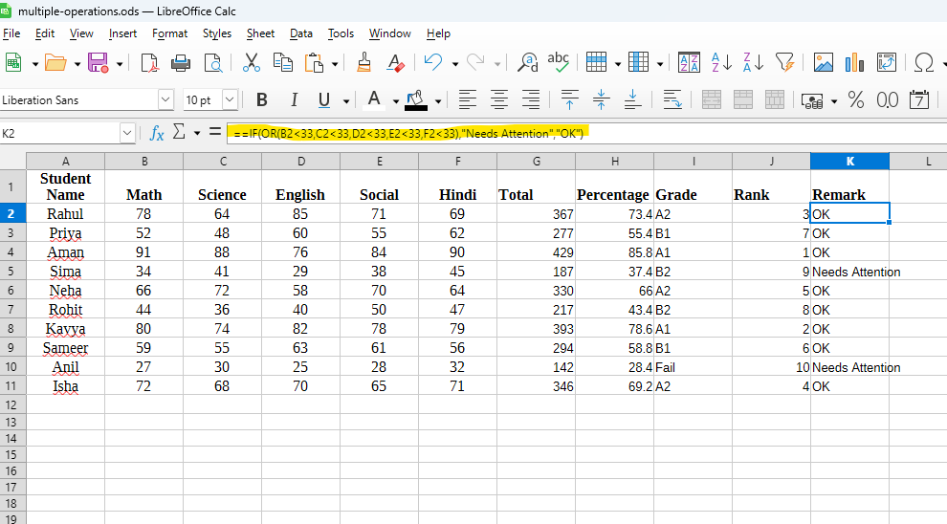

Practical 4: Create subtotals in Calc

Objective:
Create a worksheet in LibreOffice Calc showing the sales of different products.
Sort the data according to the Category column and use the Subtotal feature to find the total sales for each category and a grand total for all products.

Step 1: Enter the data
Type the following data in a new Calc sheet.
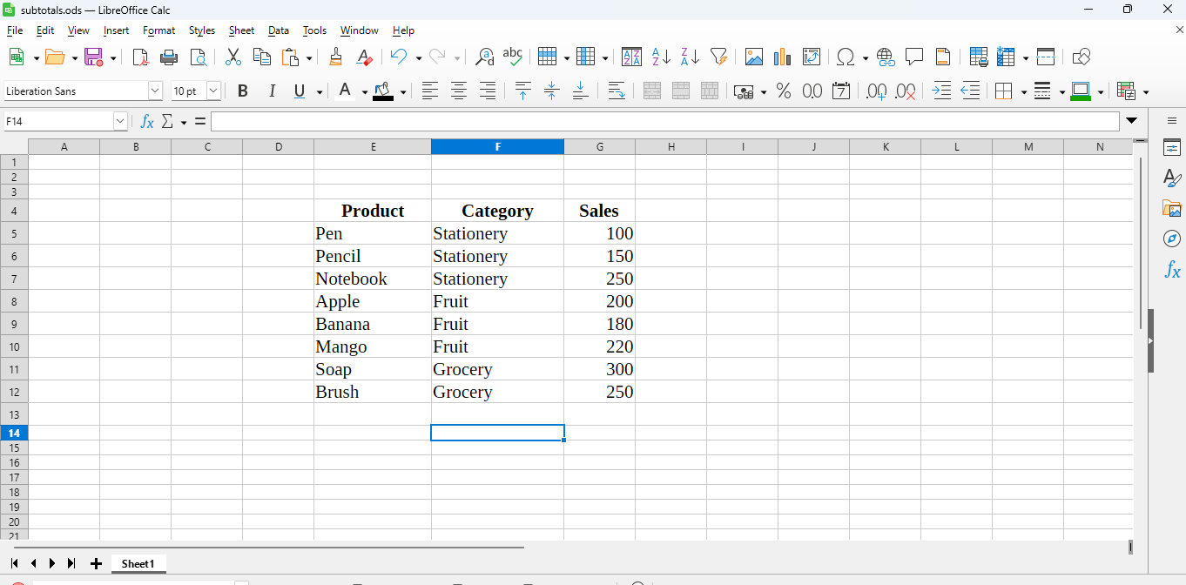
Step 2: Sort the data
Before using Subtotals, you must sort the data by Category.
- Select the range E4:G12.
- 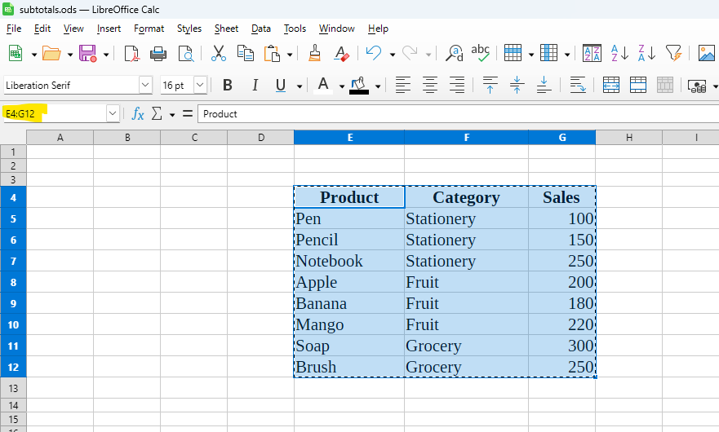
- Go to Data → Sort.
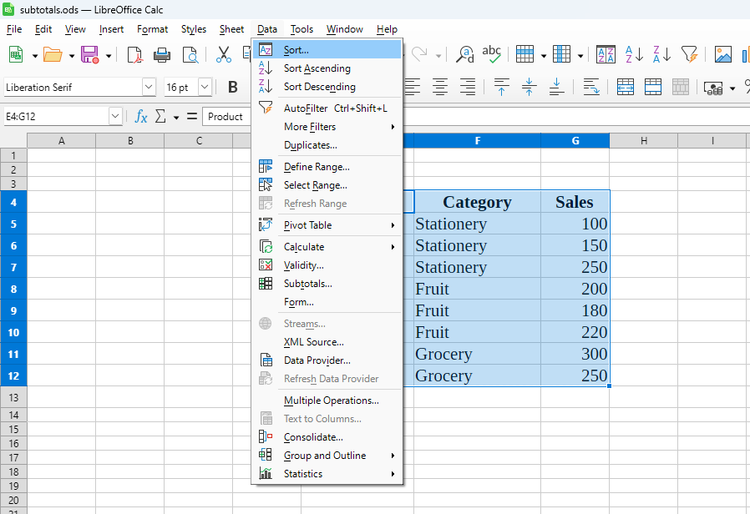
- In the dialog box:
  - Choose Category as the Sort Key .
  - Click ok
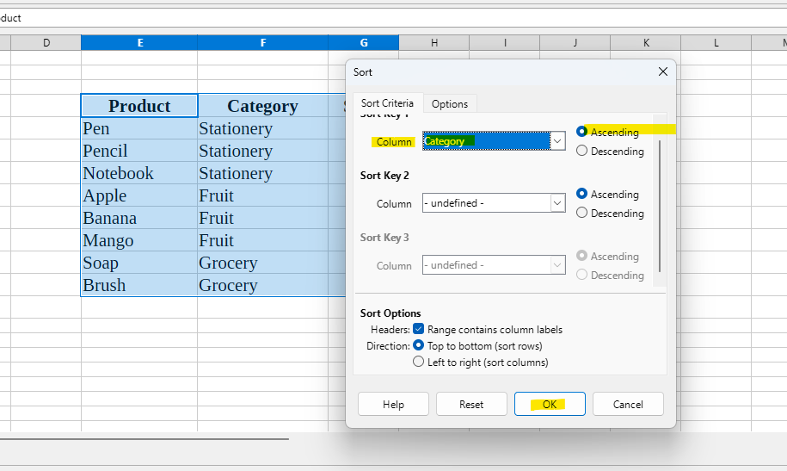
Now your data will be arranged as per the Category (Stationery, Fruit, Grocery).
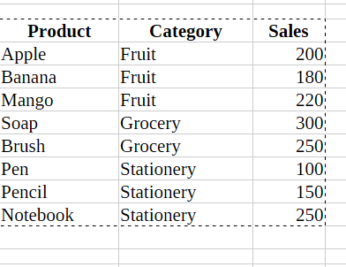

Step 3: Apply Subtotals
- Again, select the same range of data (E4:G12).
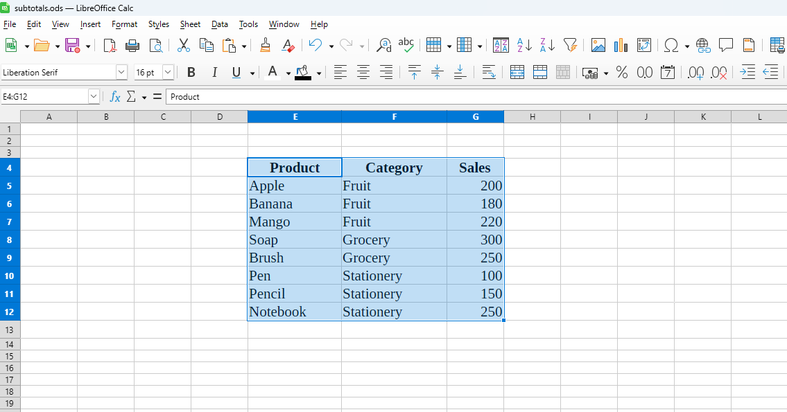
- Go to Data → Subtotals.
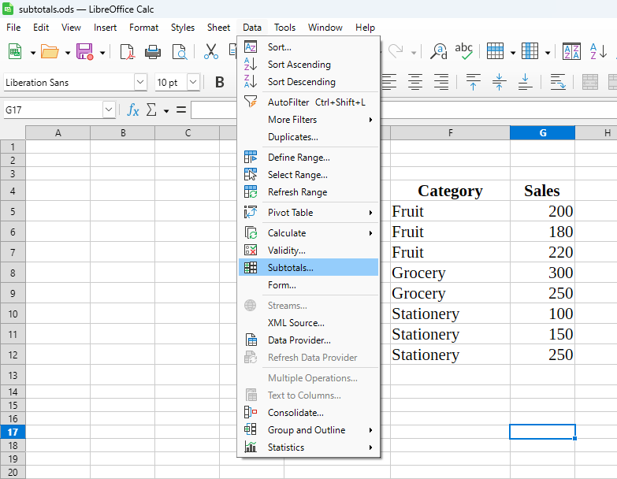
- In the dialog box:
  - Under Group by, select Category.
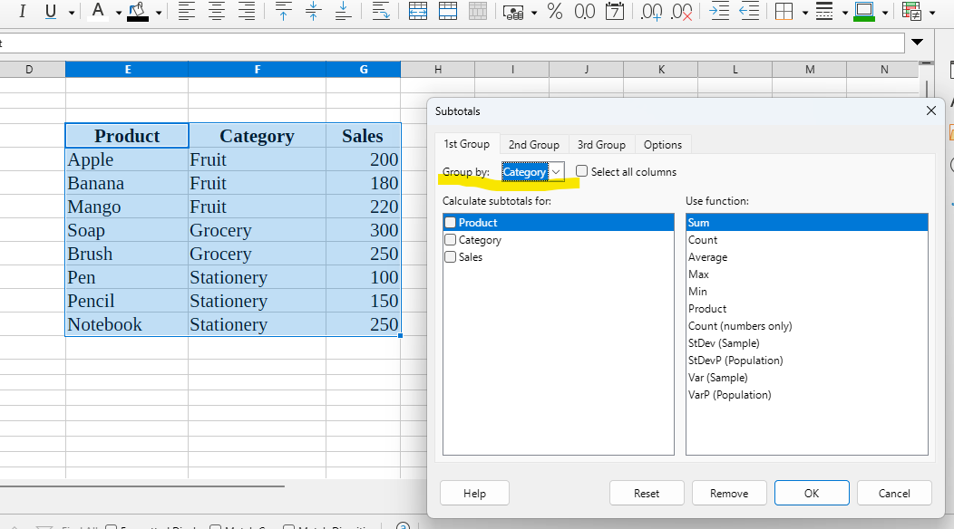
  - Under Calculate subtotals for, tick Sales.
  - Under Use function, select Sum.

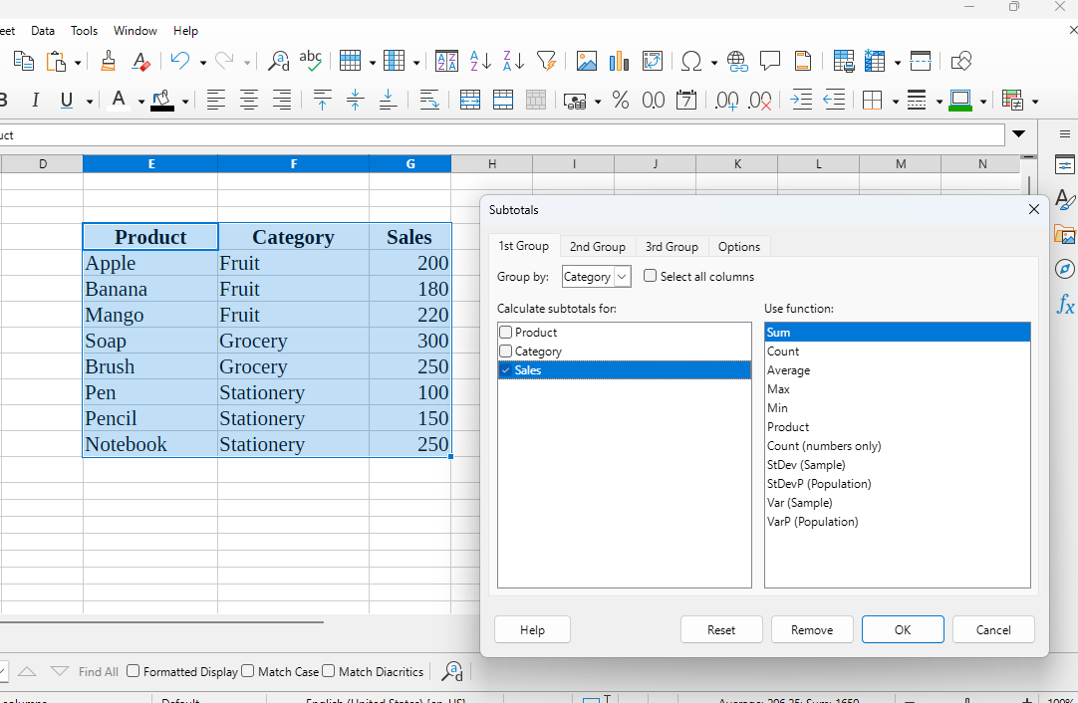

- Click OK.
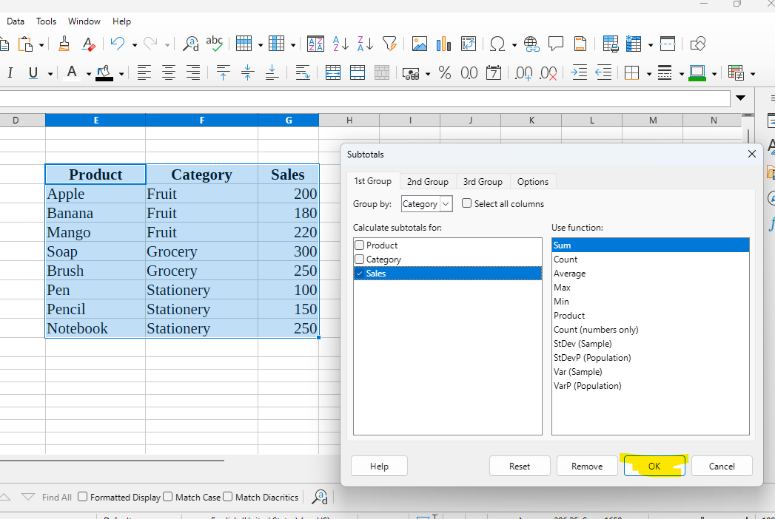

Step 4: View the result
Calc will insert subtotal rows automatically for each category and a Grand Total at the end.
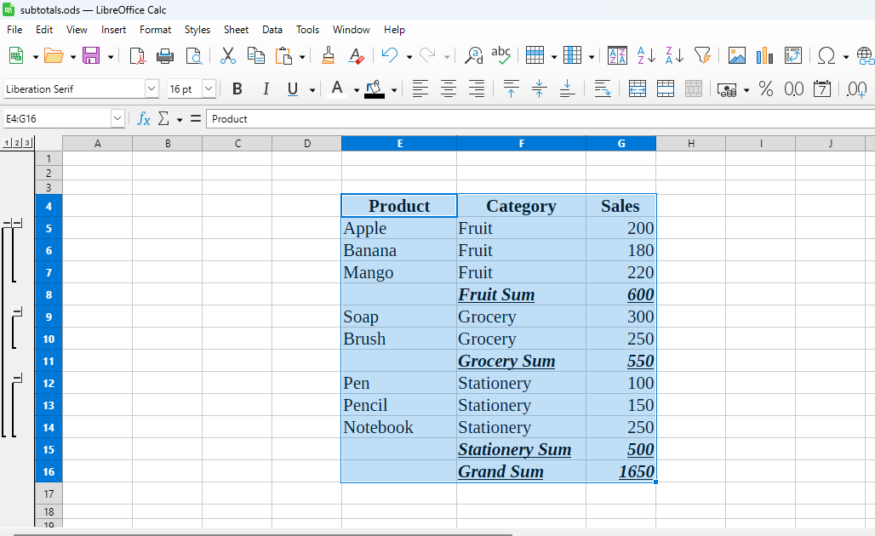

Practical 5: Scenario

Objective:
Use LibreOffice Calc’s Scenarios to compare Total Profit under different Cost Price / Selling Price assumptions.

Problem Statement
A company sells three products — Pen, Notebook, and Eraser. Using the given data, calculate profit per product and total profit. Then create three scenarios (Normal, Best, Worst) that change Cost Price (CP) and Selling Price (SP) and compare the Total Profit using Scenario Manager.

Solution:
Step 1: open new calc spreadsheet sheet
- Enter the details
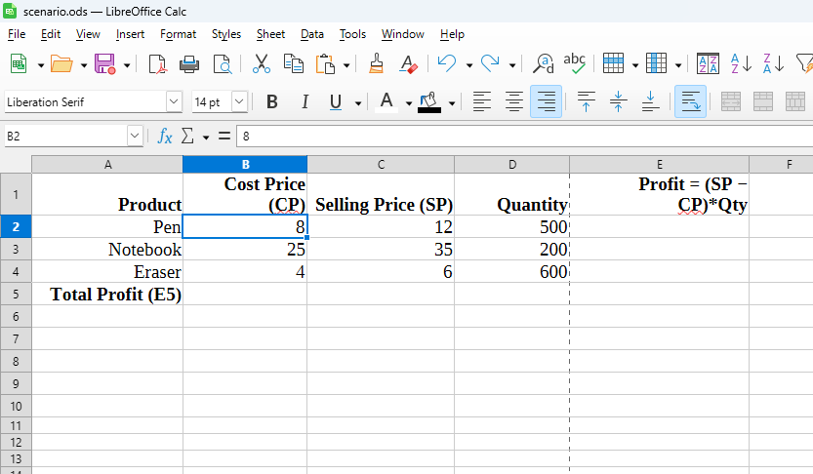
Step 2 – Calculate Profit for each product
In E2, enter the formula:
=(C2-B2)*D2
Fill down to E4.
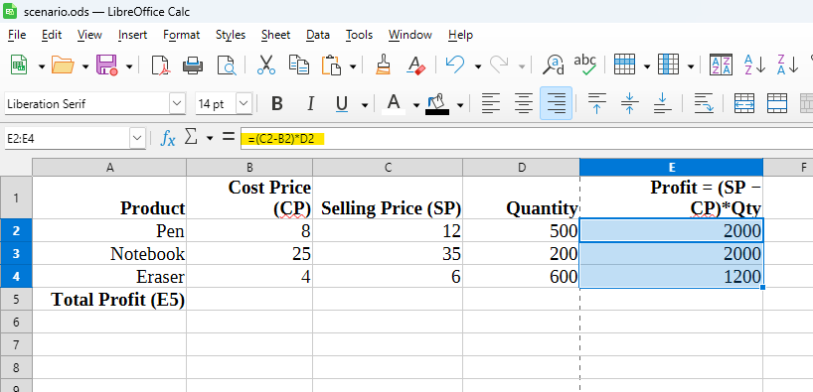

In E5, calculate total profit:
=SUM(E2:E4)
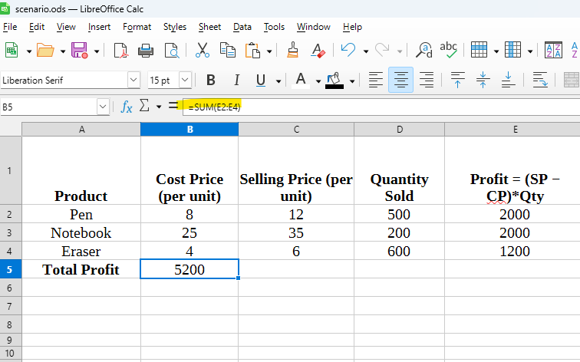
=SUM(E2:E4)
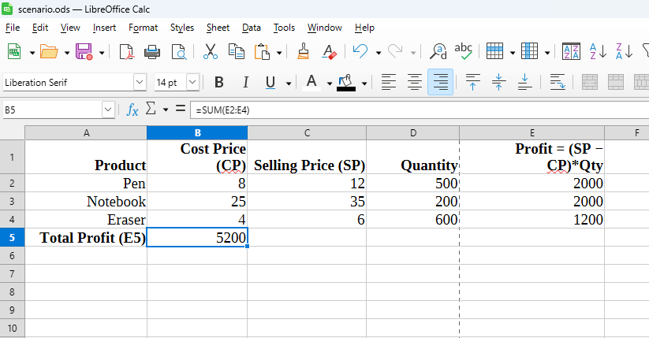

Step 2 — Plan scenarios
Create three scenarios:
- Normal Case — keep current CP and SP (baseline).
- Best Case — SP increases by 10%, CP decreases by 5%. (SP × 1.10, CP × 0.95)
- Worst Case — SP decreases by 10%, CP increases by 5%. (SP × 0.90, CP × 1.05)
We will change values in columns B (CP) and C (SP) under each scenario and read result cell E5 (Total Profit).

Step 3 — Create scenarios in LibreOffice Calc
- Select the range B2:C4 (these are the cells that will change between scenarios).
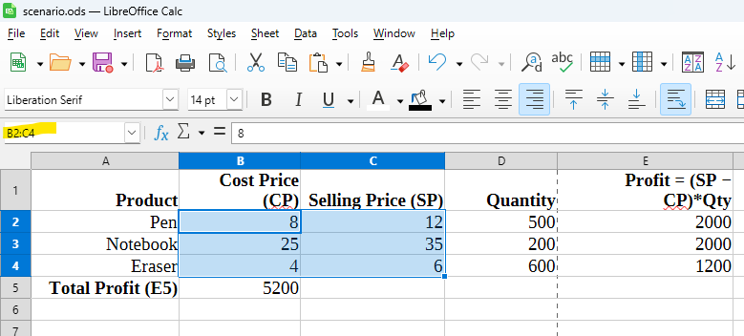
- Menu: Tools → Scenarios... → click Add.
  - Name: Normal Case
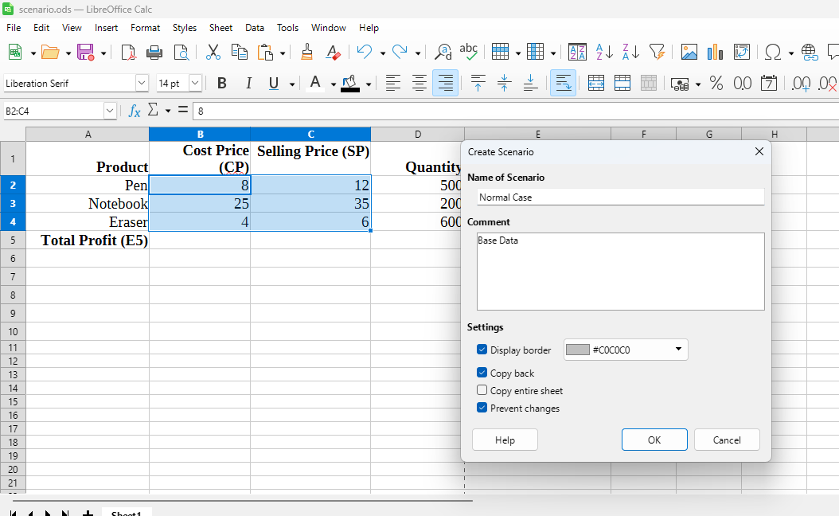
  - Description: Base data
  - Click OK (this saves current values as the Normal Case).
- Click Add again → Name: Best Case.
  - Now you must supply the new values for the selected cells. Instead of typing formulas here, change the actual values in B2:C4 temporarily (do it on the sheet) to the Best Case numbers, then click Add with those values visible.
  - With B2:C4 showing these Best Case values, press Add in the Scenarios dialog and name it Best Case.
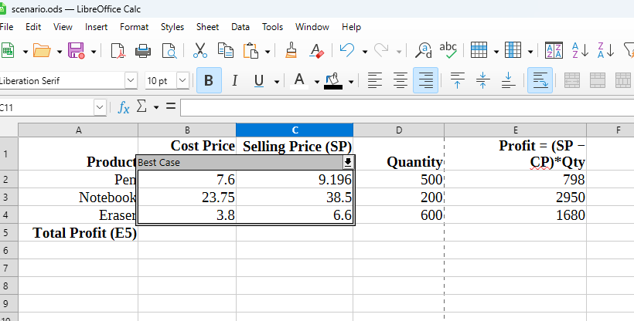
- Restore the sheet to base values (or use Undo) so you still have Normal Case active.
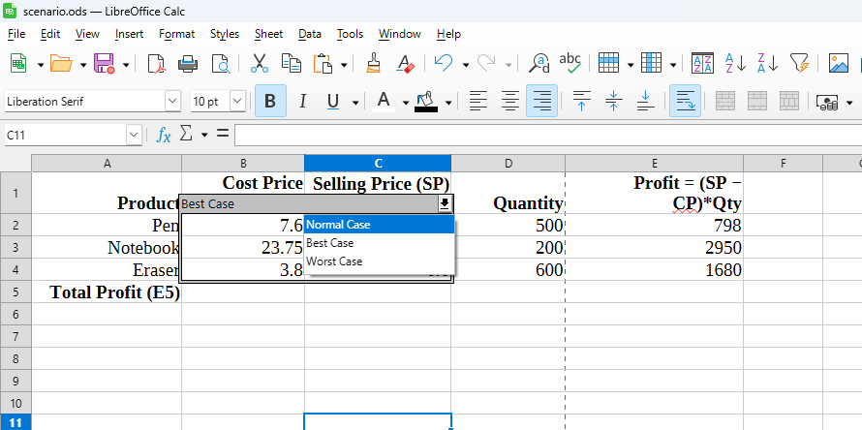
- Repeat to create Worst Case:
